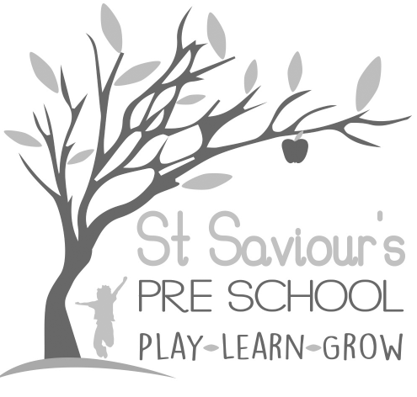
2.2 STUDENT PLACEMENTS

Written by: Claire Toms and Tina Alder Date: 1.09.22. – reviewed 28.8.25.

When we do offer placements, we will follow the following procedures.

Policy Statement
We recognise that qualifications and training make an important contribution to the quality of the care and education we provide. As part of our commitment to quality, we offer placements to students undertaking early years qualifications and training. We also offer placements for school pupils on work experience.
We aim to provide for students on placement with us, experiences that contribute to the successful completion of their studies and that provide examples of quality practice in early years care and education.

Procedures
- We require students on qualification courses to meet the suitability requirements of the EYFS 2025 and have a satisfactory enhanced DBS check with barred list check(s).
- We require students in our setting to have a sufficient understanding and use of English to contribute to the well-being of children in our care.
- We require schools, colleges or universities placing students under the age of 17 years with us to vouch for their good character.
- We always supervise students under the age of 17 years and do not allow them to have unsupervised access to children.
- Students undertaking qualification courses who are placed in our setting on a short-term basis are not counted in our staffing ratios.
- Trainee staff and students over the age of 17 may be included in the ratios only if they are deemed competent, responsible, and working towards a recognised early years qualification in line with EYFS 2025 requirements.
- We take out employers’ liability insurance and public liability insurance, which covers both students and voluntary helpers.
- We co-operate with students’ tutors to help students to fulfil the requirements of their course of study.
- We provide students, at the first session of their placement, with a short induction on how our setting is managed, how our sessions are organised and our policies and procedures.
- Students must read and sign to confirm understanding of our safeguarding policy, code of conduct, and confidentiality procedures before beginning their placement.
- We communicate a positive message to students about the value of qualifications and training.
- We make the needs of the children paramount by not admitting students in numbers that hinder the essential work of the setting.
- We ensure that trainees and students placed with us are engaged in bona fide early years training, which provides the necessary background understanding of children’s development and activities.
- Child Studies – Permission must be sought from the parent of the child involved. If appropriate, we would have to inform all other parents of the student’s intentions and reassure them that no notes would be made/photographs taken of children, other than the one to be studied.
- Observations carried out in our setting must be under the supervision of the leaders and notes should be made available to us on request. Any information would be kept confidential to the student, tutor, parents involved and the leaders. Students must read and respect our Code of Confidentiality.
- If at any time, we should have concerns that the observations are having adverse effects on any of the children, we reserve the right to terminate the arrangement immediately.
- All students are expected to uphold the same professional standards as staff, including safeguarding children from harm, promoting positive behaviour, and modelling respectful interactions in line with EYFS 2025.

